Historical Notes regarding River to the Sea

By 1850, Wilmington was the largest city in North Carolina. During this time, some of our most impressive structures were built including Thalian Hall, the Latimer House and the Bellamy Mansion. We are recognized in the National Register of Historic Places.
DIVISION I – Area Mansions
The Bellamy Mansion, built between 1859 and 1861, is a mixture of Neoclassical architectural styles, including Greek Revival and Italianate. Designed by architect James F. Post for the wealthy physician and merchant Dr. John D. Bellamy.
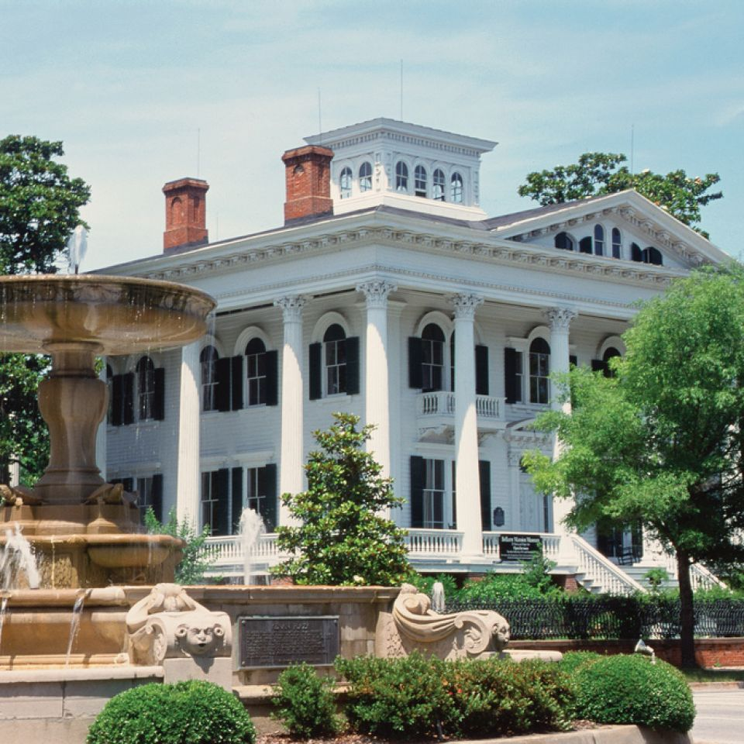

“Lock Me Up” – The Burgwin-Wright Home. Built in 1770, this house and gardens are the only structures in Wilmington from the colonial era (open to the public). Experience Georgian architecture and pre-revolutionary Wilmington. It is surrounded by exquisite gardens in seven distinct areas. Constructed on the ballast stone walls of the former city jail – the house retains vestiges of its previous incarcerations, and we will utilize the outdoor jails cells for a few of our design displays.

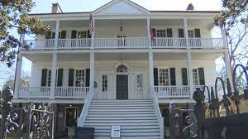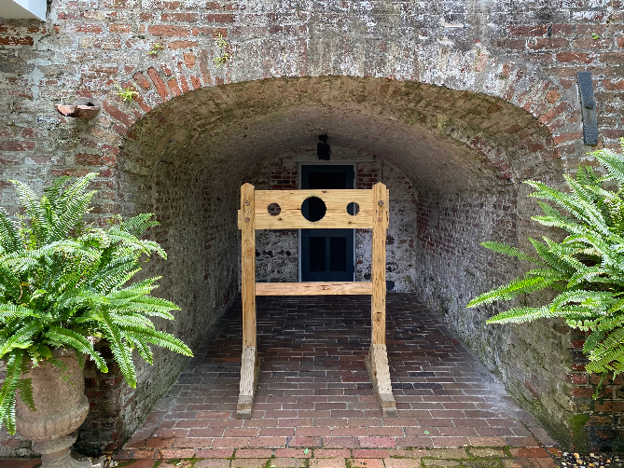

Orton Plantation – A historic plantation house beside the Cape Fear River built in 1735 – one of the oldest structures in Brunswick County. Ownership of the home was passed down to each generation of the Sprunt family for 126 years. It was a working rice plantation during its earliest years.

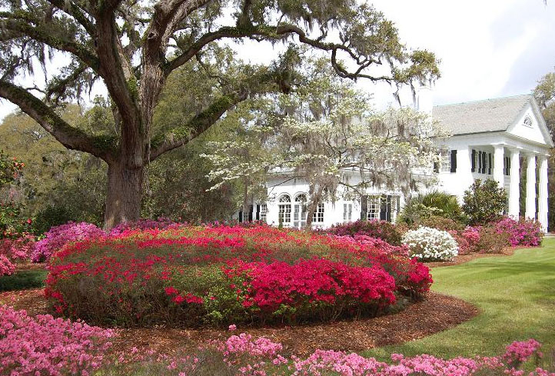

Latimer House – The house was built for commission merchant Zebulon Latimer and his wife, Elizabeth in 1852 during Wilmington’s antebellum housing boom. The Italianate Revival House emulated the villas from antiquities. Currently open as a museum it boasts over six hundred objects original to the home. The Harbor Island Garden Club has decorated rooms/porches for the Candlelight tour in years past.

Dudley Mansion – this gracious 12,500 square foot estate overlooks the Cape Fear River and is in the heart of downtown Wilmington’s historic district. Originally built for the first popularly elected governor of North Carolina – Edward Bishop Dudley. Later owners included Pembroke and Sarah Jones.

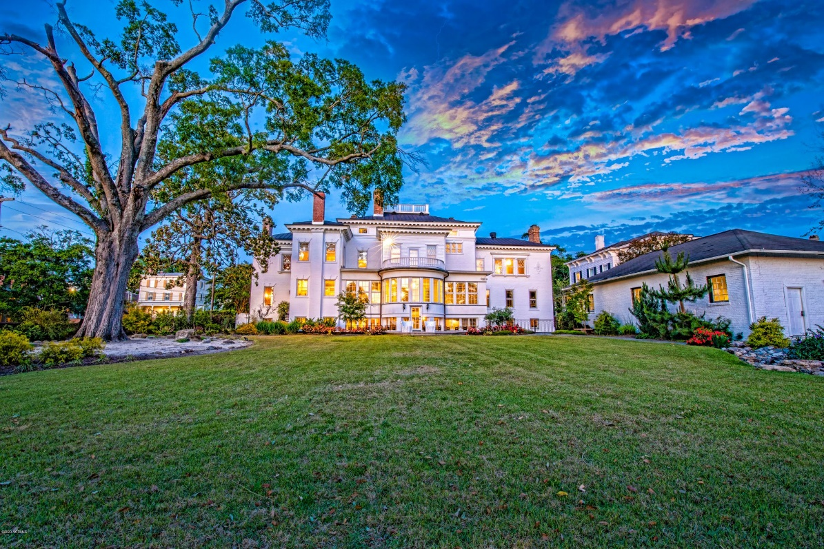

The de Rosset House – The de Rosset house is one of Wilmington’s earliest residences built in 1841 by Dr. Armand John de Rosset III. The de Rossets were fond of entertaining and the architectural plans for the house were designed to accommodate the many social events they hosted. Known today as the City Club.
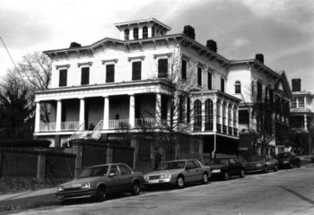
DIVISION II – “Keeping Up with The Jones’”
If you have ever heard the term “Keeping up with the Jones’” – local lore says this term was coined for Sarah and Pembroke Jones who developed Airlie Gardens and owned multiple homes around the country. They were dear friends of the Vanderbilts. Mr. Jones also built a “bungalow” get-away large hunting lodge on 2,200 acres called Pembroke Park – which is now Landfall. Here, the Jones’ friends would go hunting with dogs imported from Europe and attend parties where musicians performed perched in the treetops. Authur Momand created a cartoon series that never featured the Jones’ but featured a family who struggled to keep up with the lifestyle of their neighbors. It must have popularized the term.

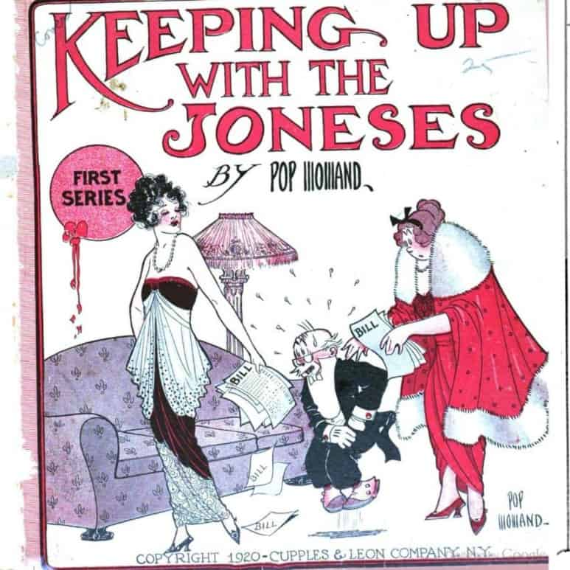
Oyster Roast at Airlie Gardens Origins – Beginning in 1905, extravagant oyster roasts were hosted at Pembroke Park (now Landfall) at the Lodge by Sarah and Pembroke. The most famous of which was the “Tree Party.” Guests arrived along Summer Rest Road. Classical musicians and adventuresome guests climbed freshly cut spiraling stairs to platforms in the giant live oaks.

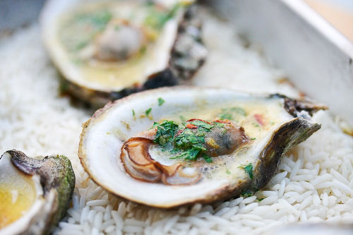
Shell Road – ran from Airlie and down Wrightsville Avenue The road was paved in shells, making passage easier for horses.

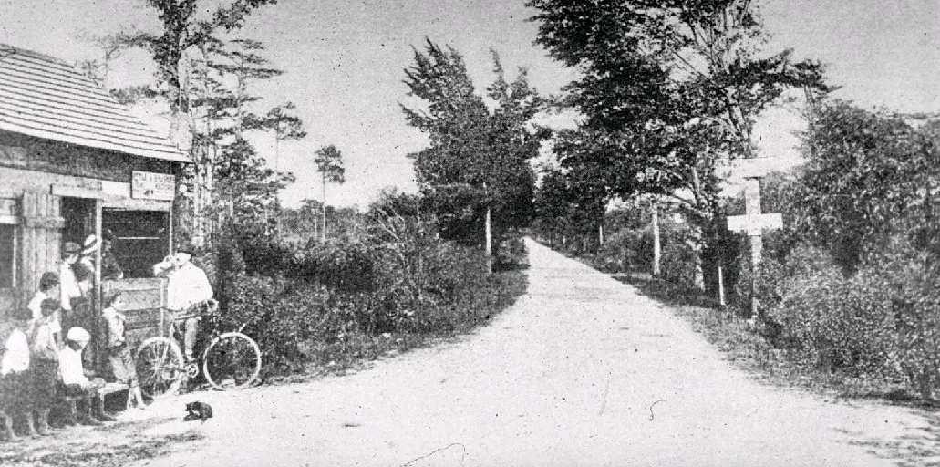
Airlie Gardens – Native Americans originally inhabited the lands, eating nuts and harvesting oysters, crabs, clams and shrimp from its clear waters. The beautiful Airlie Live Oak tree was an acorn beginning to grow in 1545. In 1884 Sarah Green and Pembroke Jones buy the parcel of land and develop the beautiful gardens and showplace of the South. The first Azalea Festival begins in 1948, with the Queen’s Luncheon Garden Party taking place at Airlie. Artist Minnie Evans and her husband shine as tour guides for Airlie beginning in 1948. In 1999, New Hanover County purchases 67 acres for a public garden.

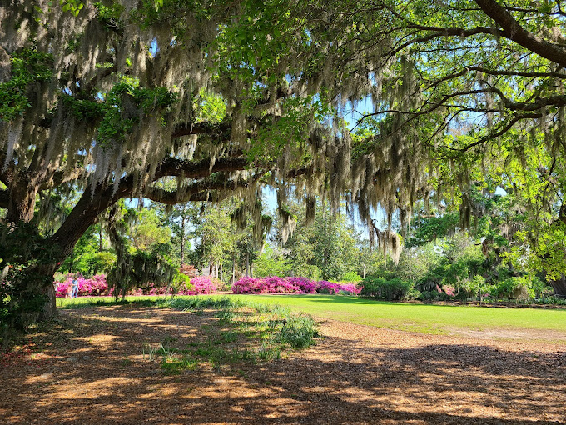

The Lumina – Built in 1905, the Lumina Pavilion on Wrightsville Beach was considered the “Fun Spot of the South”. It was built to promote beach tourism and electricity. The ground floor featured dressing rooms, refreshment stands and other amusements. The second level was a dance floor and a band shell. Supposedly the Shag was invented here in 1928. There was even an outdoor movie theatre on the beach. The Lumina was the halfway stop between New York City and Cuba – so many of the Big Bands played there.

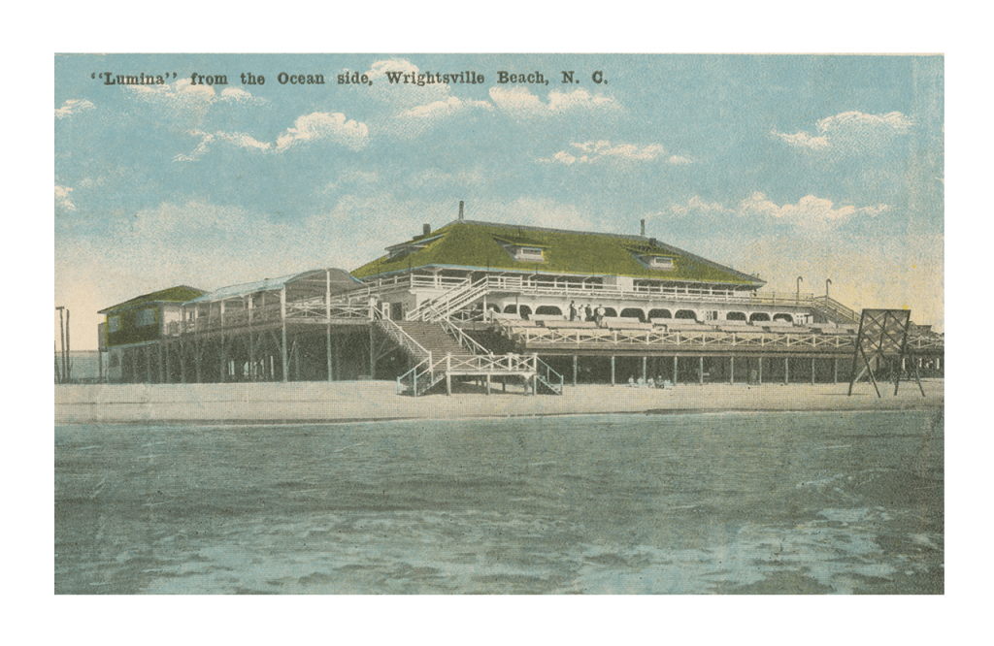
The Port City
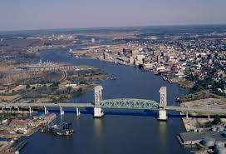

Holiday Flotilla –

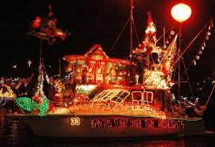

Edward Teach and The Queen Anne’s Revenge –

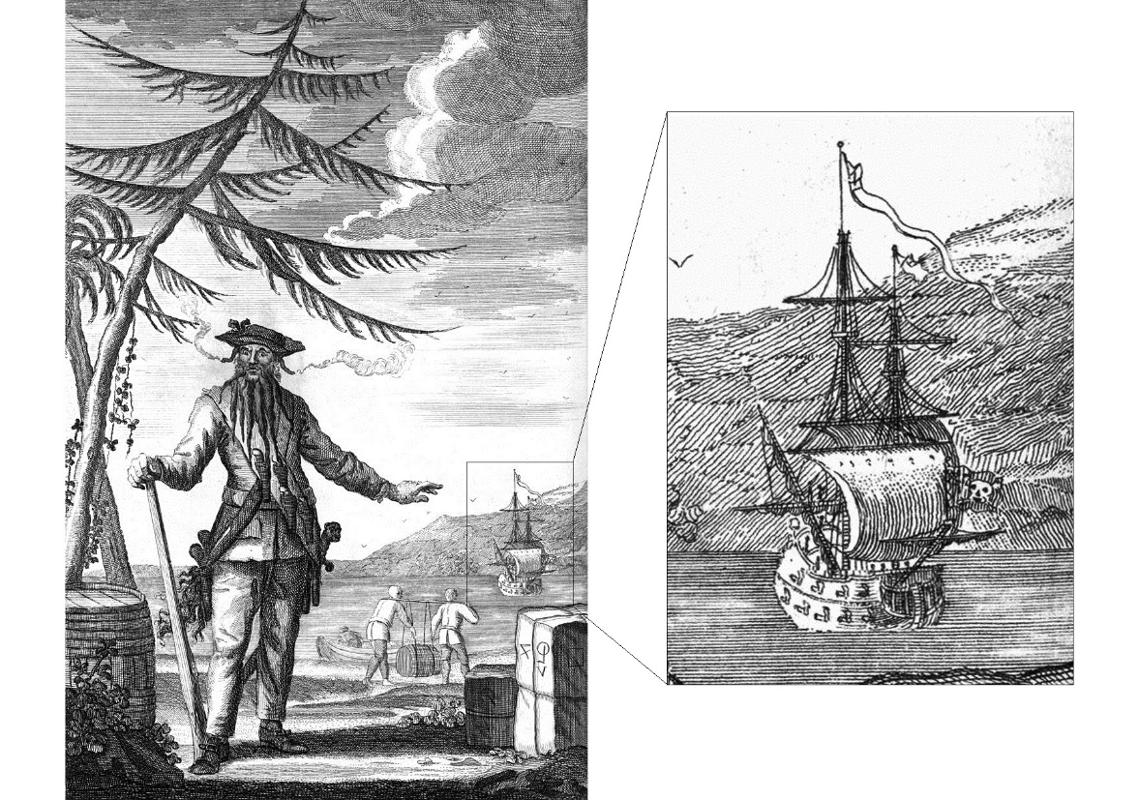

Carolina Yacht Club
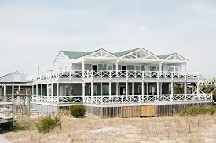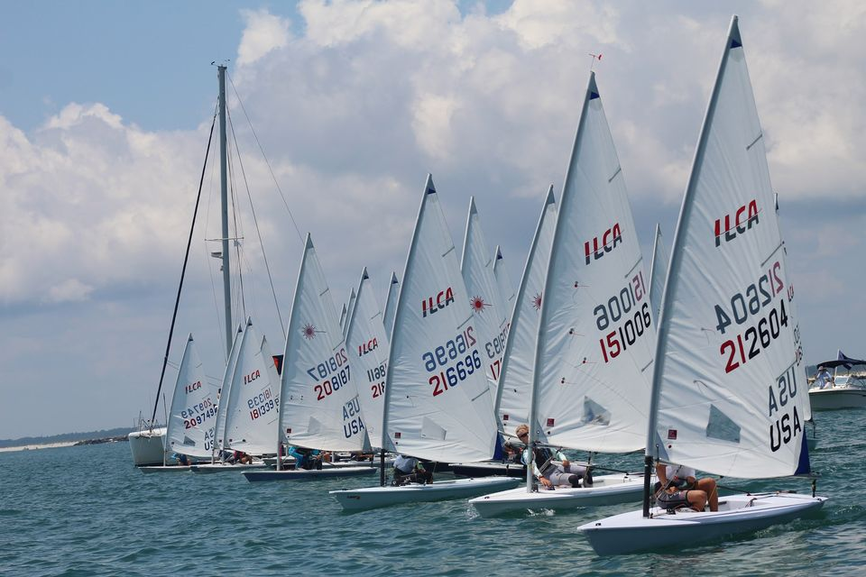

Minnie Evans –

